Baseline Energy - Analysis Report

The baseline energy function **compares energy use during operating hours (workhours) and outside operating hours (after-hours) for heating, cooling, and electricity.** This function is intended to help the user assess the effectiveness of schedules and their ability to reduce energy use outside of the building's operating hours. Plots are generated which compare the rate of energy use during and outside operating hours with respect to outdoor air temperature, and predict energy consumption at representative outdoor air temperatures - these are done separately for heating, cooling, and electrcity. The generated key performance indicators (KPI) quantify schedule effectiveness and afterhours energy use. More information is found in the respective sections.

# Visuals

The first set of visuals (to the left) compare the rate of energy use during operating hours (workhours) and outside operating hours (after-hours) as a function of outdoor air temperatures - this is done separately for heating, cooling, and electricity. Current schedules may be ineffective at reducing after-hours energy use if the after-hours energy use line is similiar or identical to the workhours energy use line. If the slope of the after-hours energy use line is shallower than the workhour eneegry use line, the current schedules are effectively reducing energy use outside operating hours.

The second set of visuals (to the right) illustrates the sensitivity of energy use with respect to outdoor air temperatures - this is done separately for heating, cooling, and electricity. If the lines are spaced considerably apart, the energy use is particularily sensitive to outdoor air temperature.

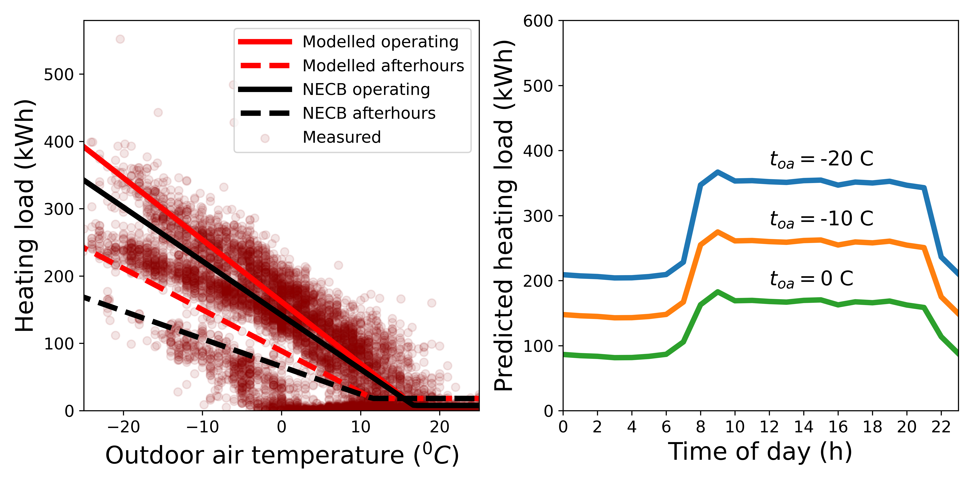

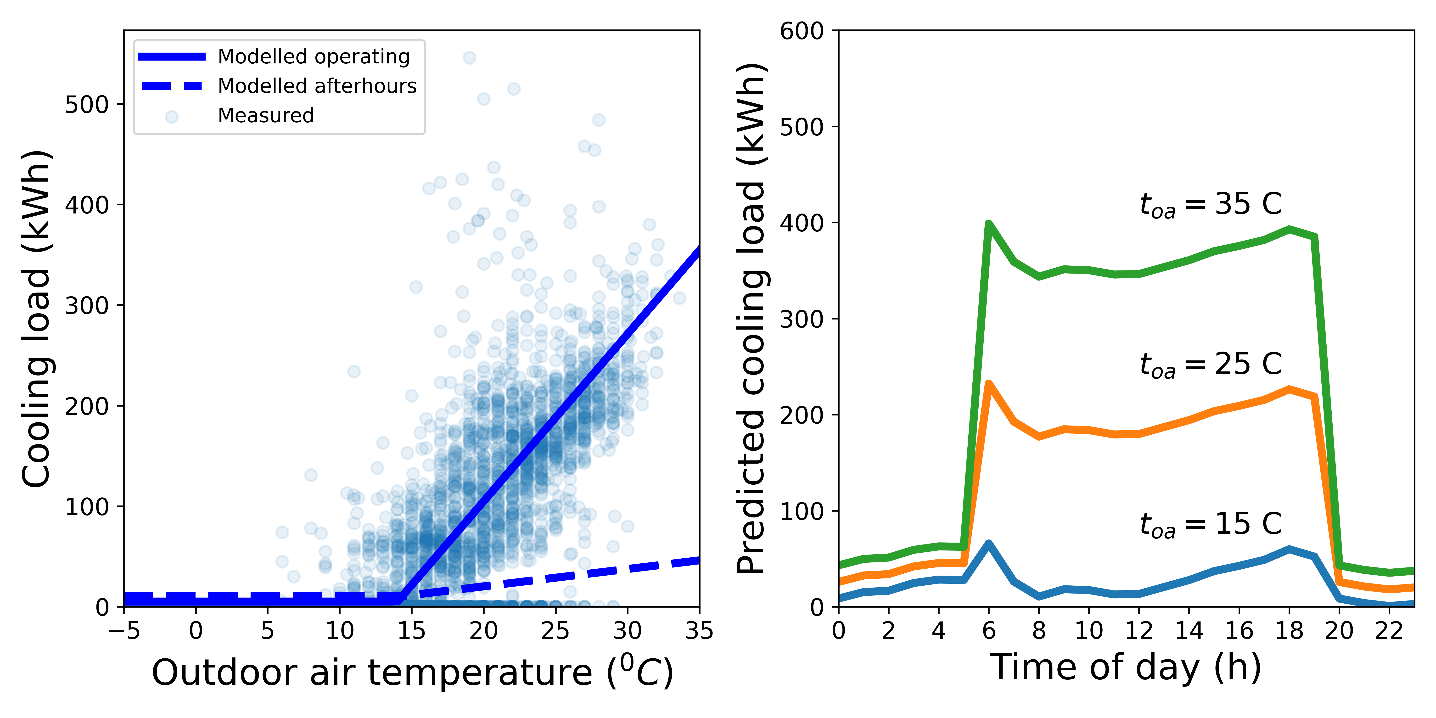

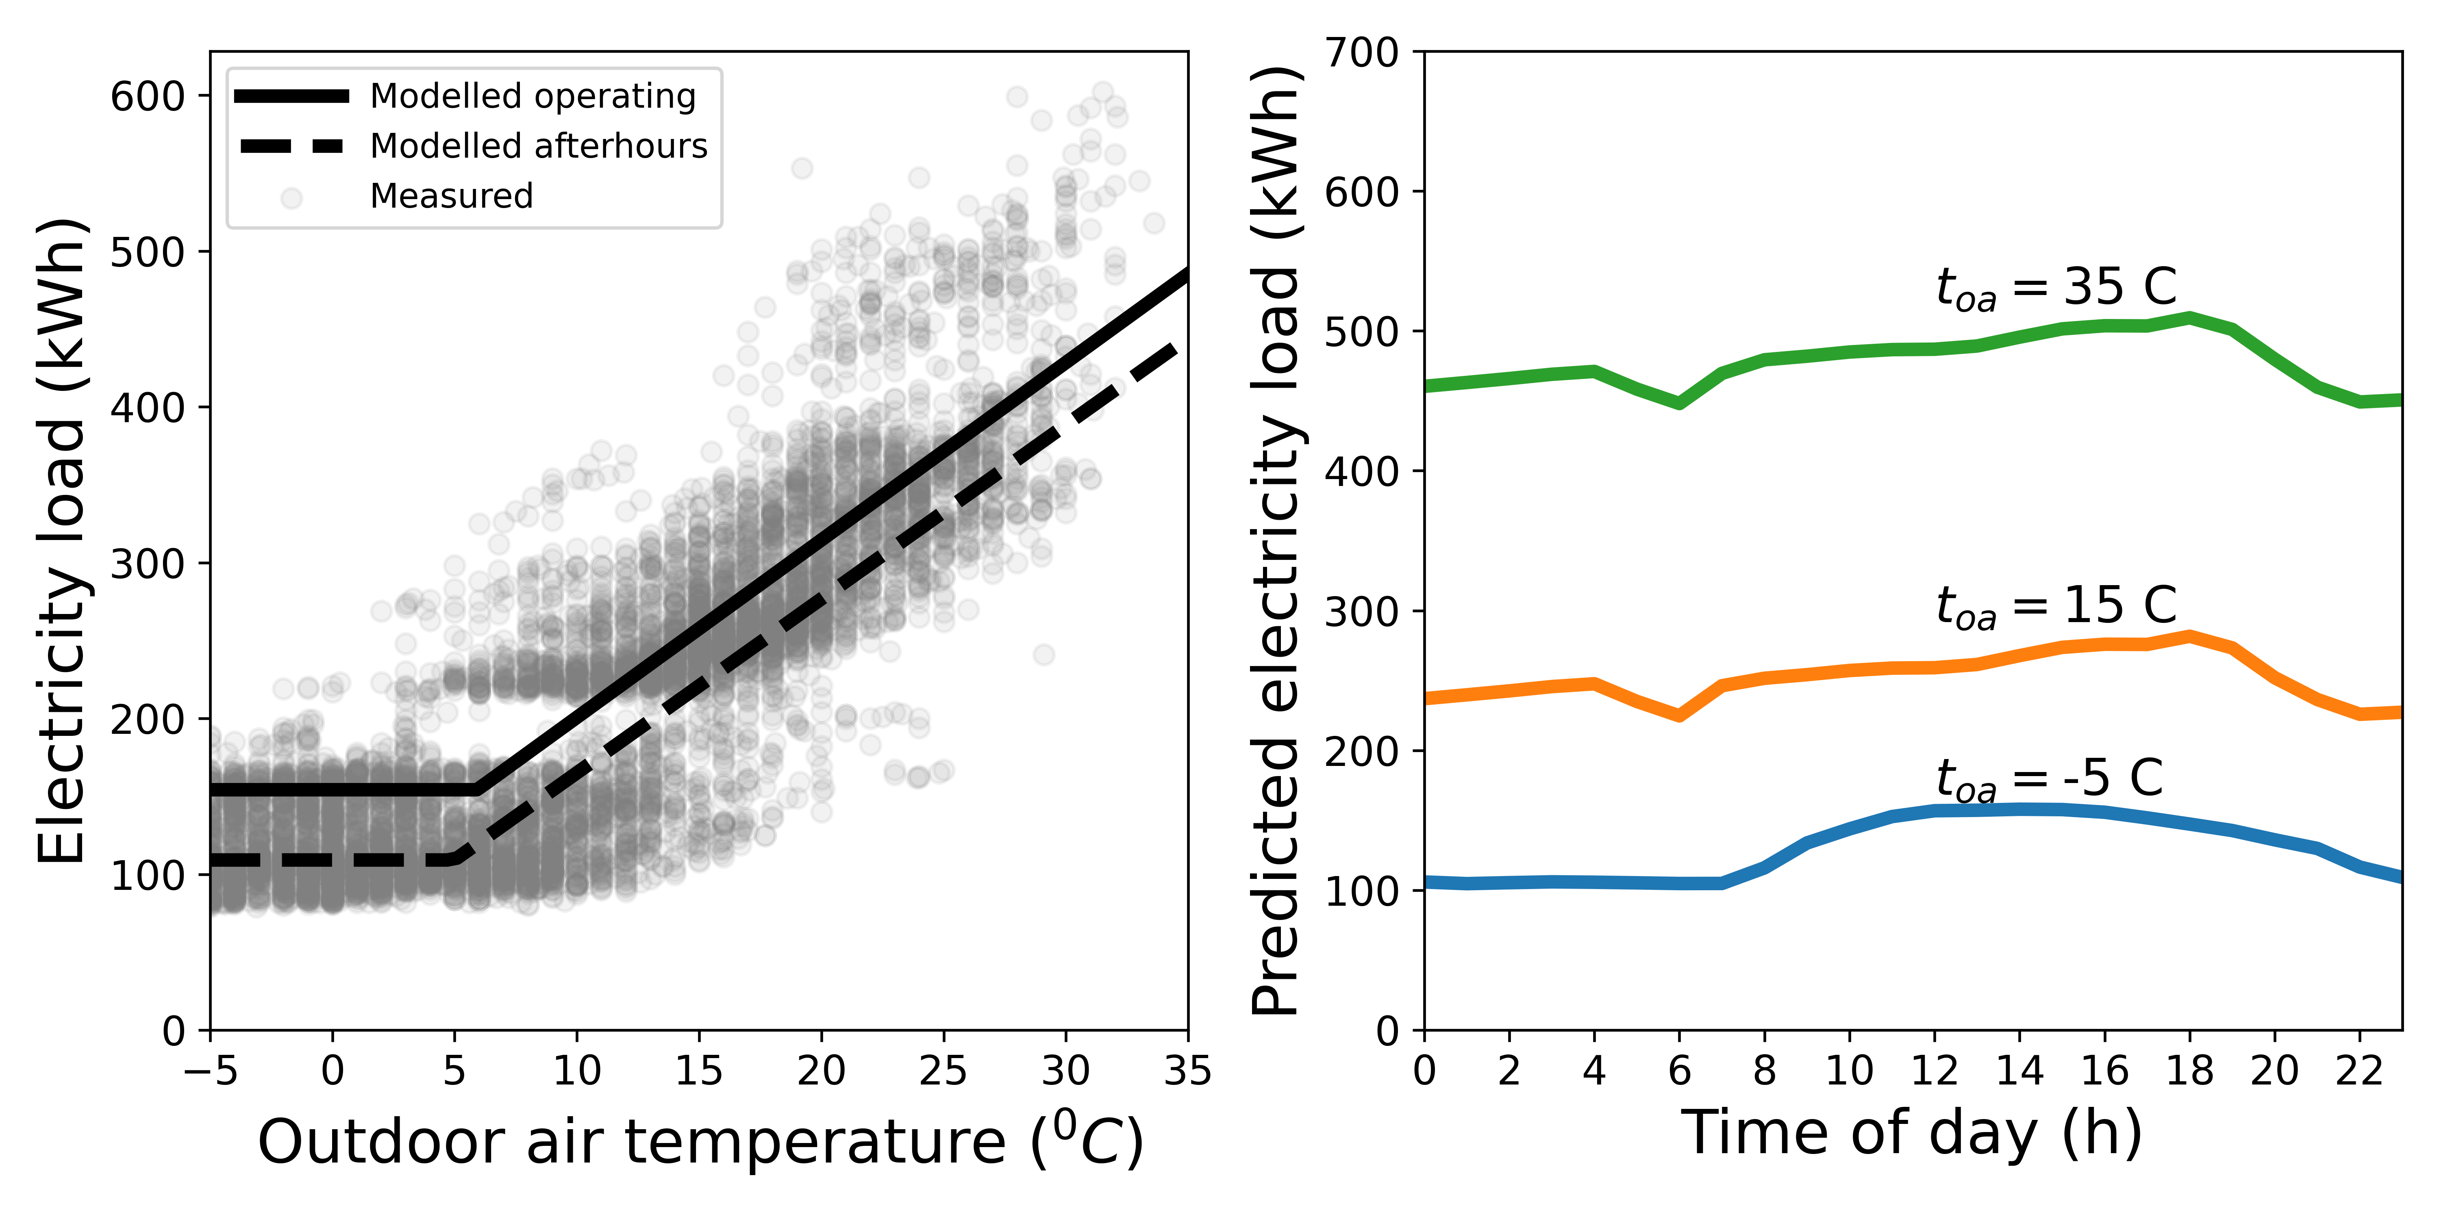

# Key performance Indicators

The key performance indicators (KPIs) are **Schedule effectiveness** and **Afterhours energy use ratio**. Schedule effectiveness quantifies the difference between the slope of the workhours energy use line and the afterhours energy use line. Values approaching zero (0%) indicate similiar or identical inclined slopes, positive (+) values indicate a steeper workhours energy use slope than afterhours, and negative (-) values indicate a steeper afterhours energy use slope. Therefore, a greater positive value is desirable since it indicates an effective reduction in energy use rates during afterhours.  
  
 The Afterhours energy use ratio is the ratio of energy use during afterhours over the total energy use. Higher value indicate a larger portion of total energy consumption used during after-hours. Therefore, a lower value is desirable.

## Schedule Effectiveness and Afterhours energy use ratio

|  |  |  |
| --- | --- | --- |
| Utility | Schedule Effectivness | After-hours energy use ratio |
| Heating | 33% | 39% |
| Cooling | 89% | 8% |
| Electricity | 1% | 49% |